Unit Test Case

Last update：2020-5-19

version：V1.0

author：Dean Peng

1. **Test Case**
2. **initial position page and transaction page records**

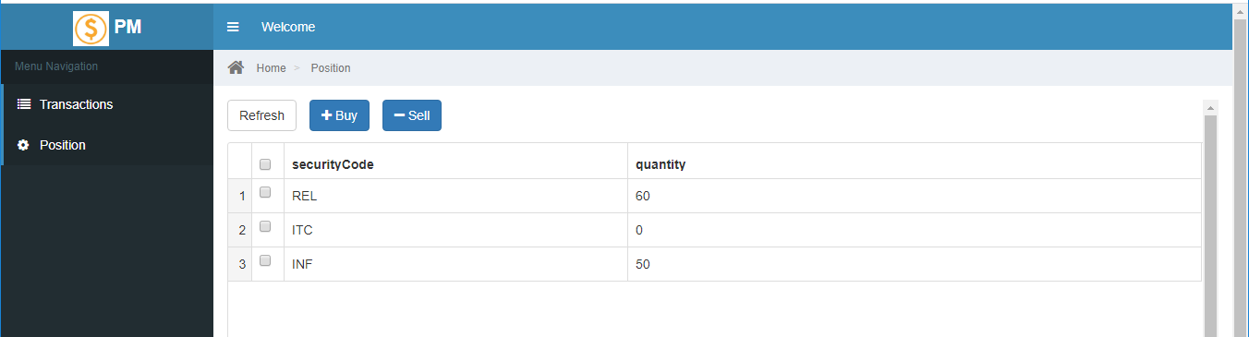

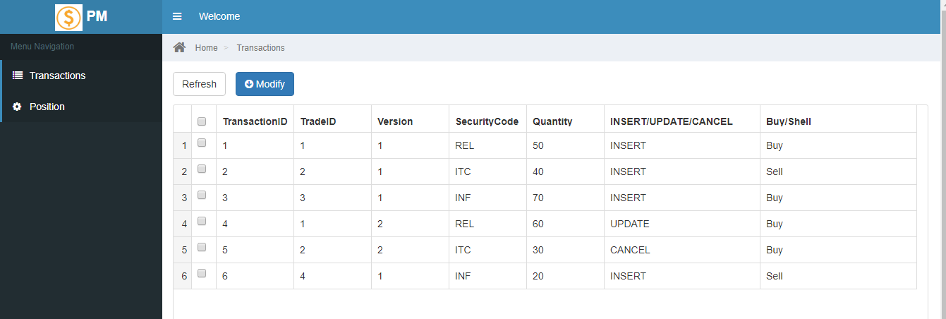

**1.1 buy “REL” quantity= 50**

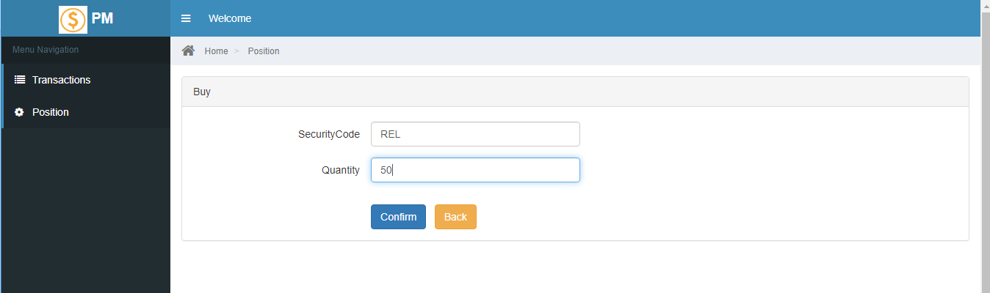

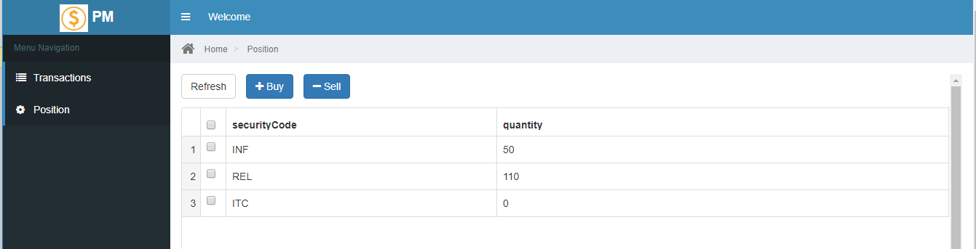

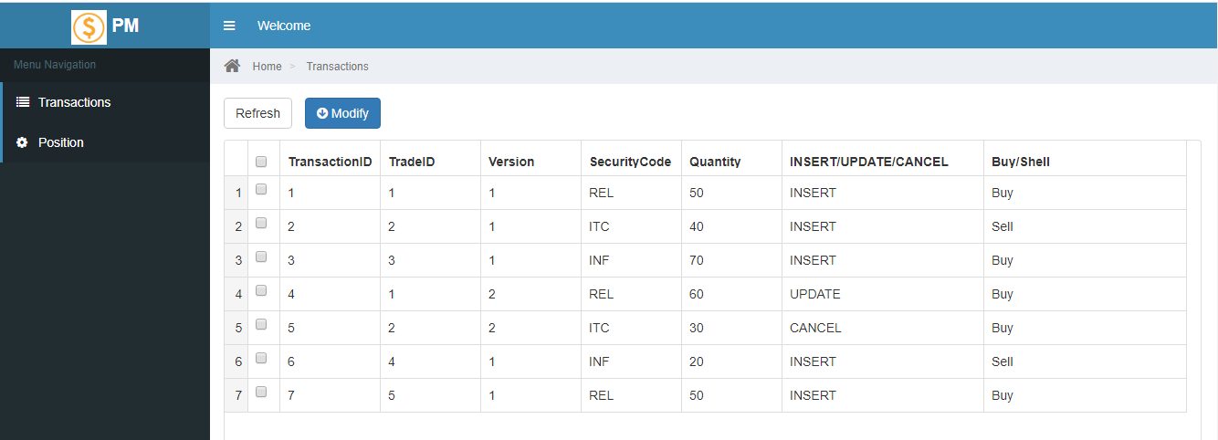

**1.2 sell “INF” quantity =20**

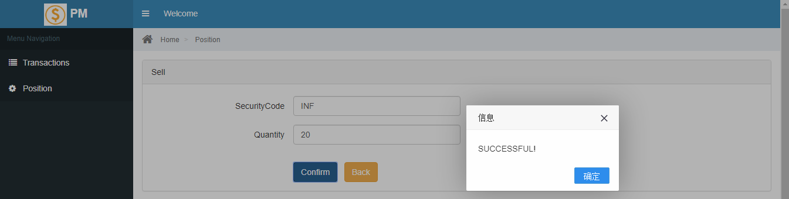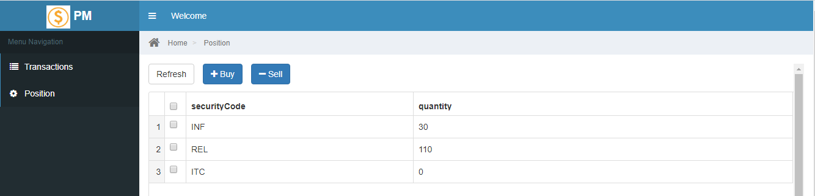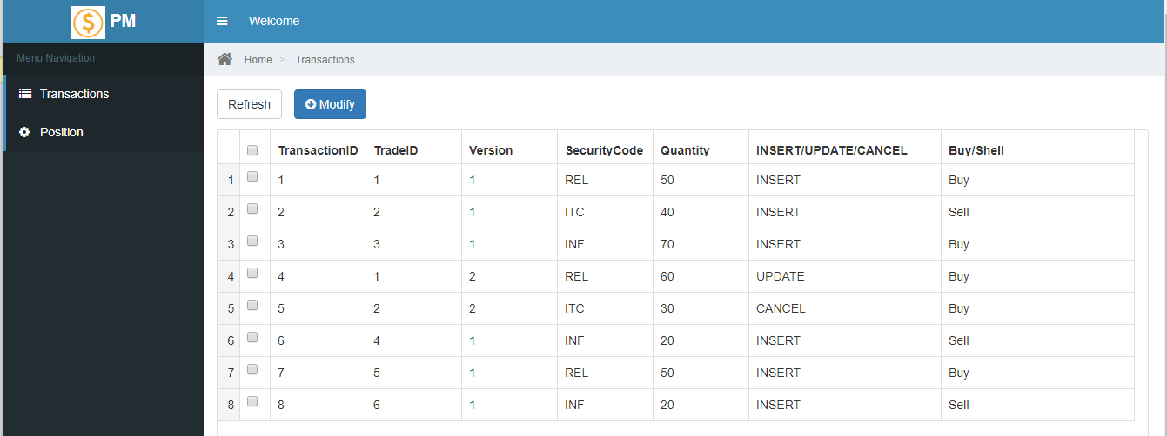

**1.3 buy “AAA” quantity=100**

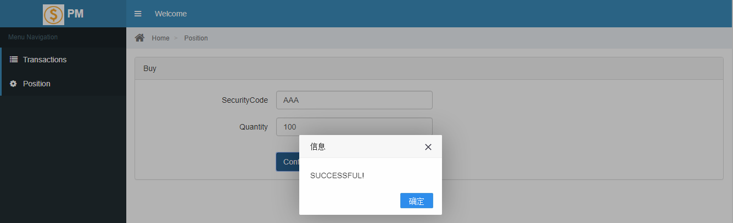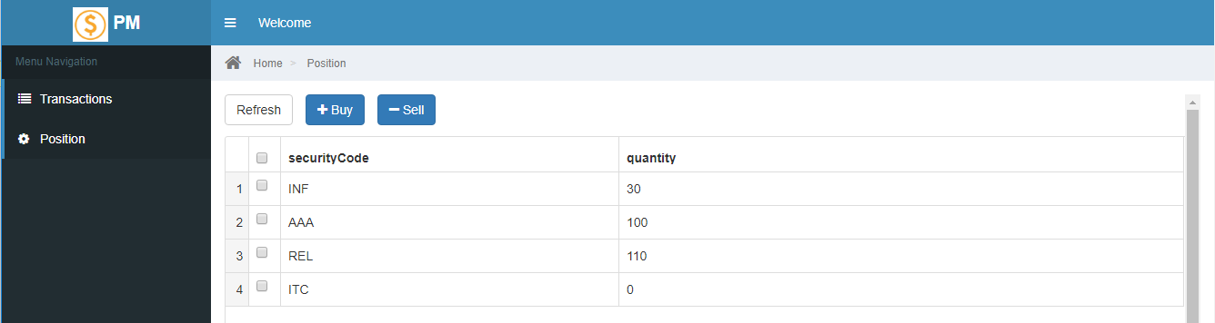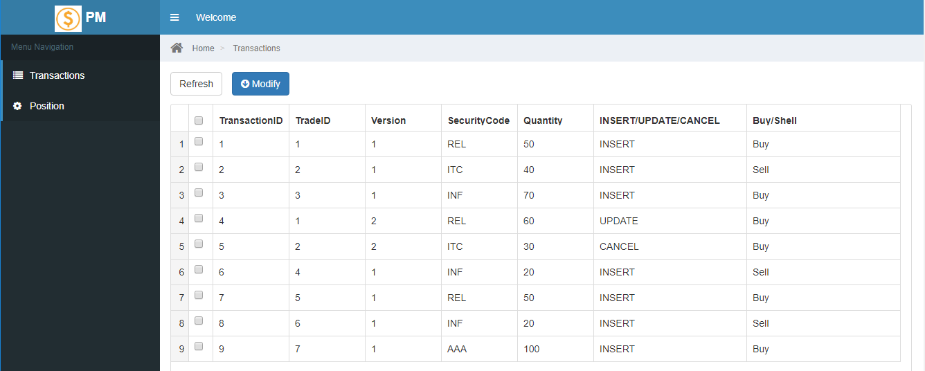

**1.4 modify transaction which tradeID=1, make quantity=80**

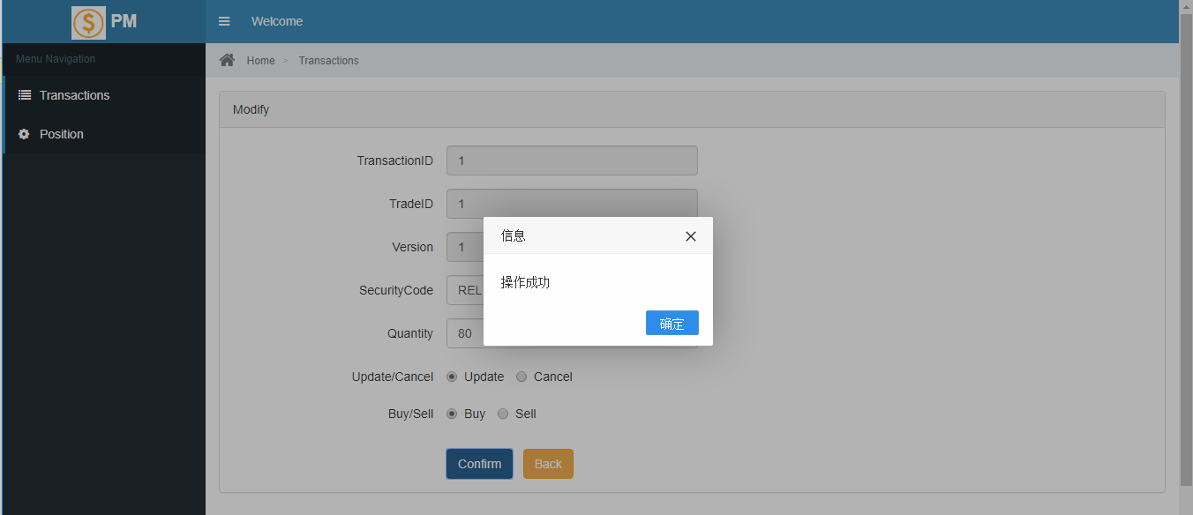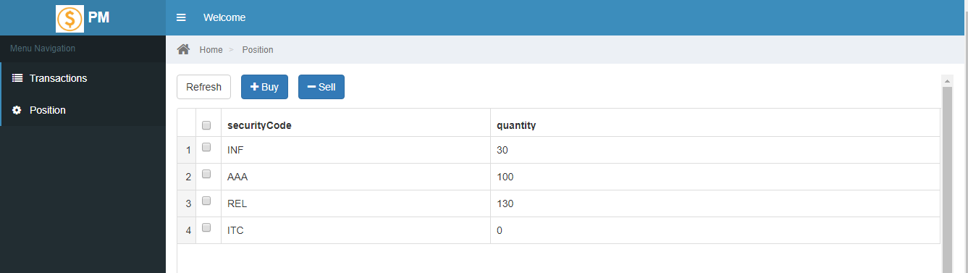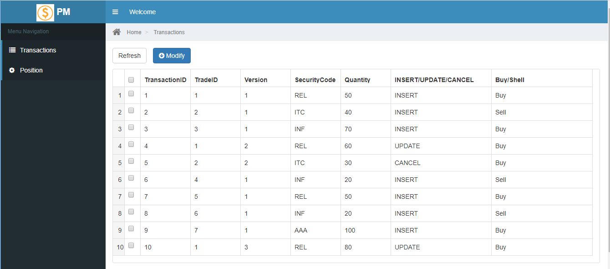

**1.5 modify transaction which tradeID=1 ,make Buy/Sell=Sell, quantity=50**

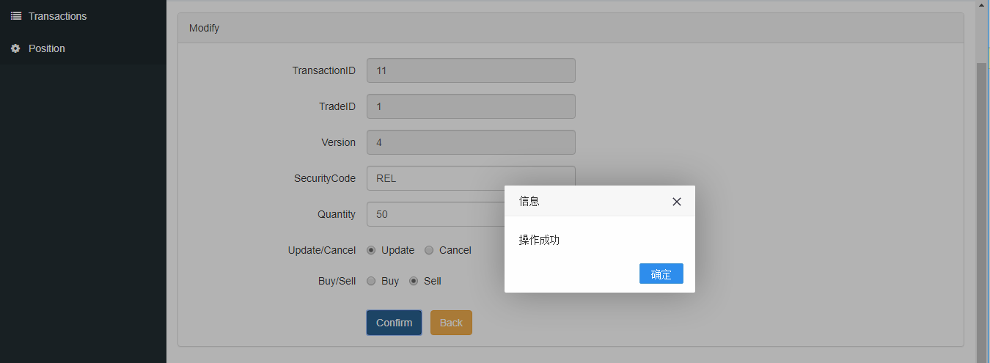

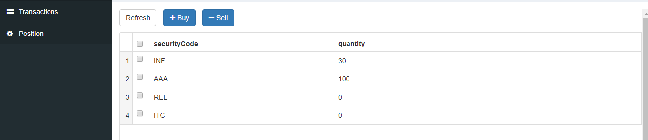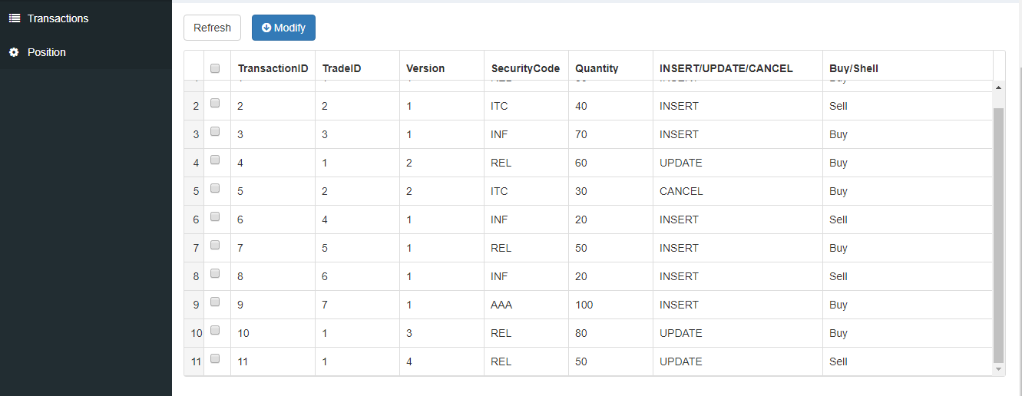

**1.6 modify transaction which tradeID=1, make Insert/Update/Cancel=Cancel**

